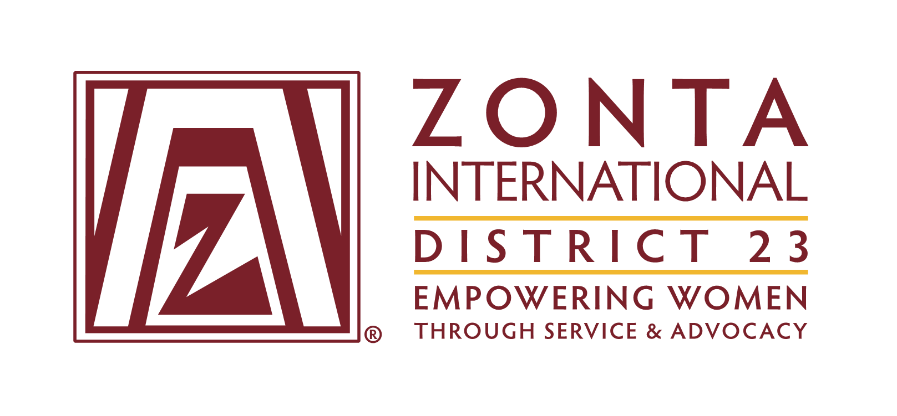

Mental Health First Aid Skills for Women in Rural Australia

Project Guide

TABLE OF CONTENTS

Section | Page number
Project background and purpose | 3
How to run a project in your area | 4
- Can any Zonta club participate? | 4
- Assigning a local coordinator | 4
- Find someone to facilitate the MHFA course in your community | 4
- Course dates and times | 5
- Venue and catering | 6
- Booking people into the course | 6
- Budget | 6
- Funding | 7
- Engaging with the community & promotion of your project | 7
- Follow up after the course | 8
- Evaluation and reporting | 8
- Evaluation forms | 8
Appendix 1 – Reflections page | 9
Appendix 2 – Evaluation form template | 10-11
Appendix 3 – Example poster | 12
Appendix 4 – Summary of actions | 13

Mental Health problems are common and significantly impact individuals and their communities. Around one in five Australian adults will experience a mental health problem in any year. Suicide is the leading cause of death for Australian’s up to the age of 44.
Project background and purpose

Zonta International District 23 wants to make a difference by providing training for adult women within their communities with Mental Health First Aid skills.

Mental Health First Aid (MHFA) is an evidence-based course that, like physical first aid, teaches community members how to provide a helpful and supportive initial response to someone experiencing a mental health problem or in a mental health crisis, such as suicide or a panic attack. It does not teach people how to be a counsellor or therapist. Anyone can be a Mental Health First Aider. (Have a look at videos of people talking about becoming a MHFAider here:
https://mhfa.com.au/i-am-one)

Evaluations of the program not only show an increase in knowledge and more support provided to others as a result of the attending the course, it also shows reduced stigmatising attitudes. Information about evaluations of Mental Health First Aid courses is available here:
https://mhfa.com.au/research/mhfa-course-evaluations

Women are often the connectors within their communities. By empowering as many women as possible within communities, more people have the skills to support someone with a mental health problem and potentially save lives. In rural or regional areas where access to professional mental health services is more limited, having mental health first aid skills throughout the community becomes even more vital. We know that someone experiencing a mental health problem is more likely to seek help, and earlier, if someone they know suggests it to them.

Imagine communities where women felt skilled and empowered to notice the signs that a friend, family member or colleague is not travelling well, and then how to help effectively. What impact might that have?
- Less stigma around mental health in the community?
- People seeking help earlier for mental health problems and therefore getting better outcomes?
- Lives saved?
- People who feel confident, and not fearful or uncomfortable, about conversations with others about their mental health?
So much is possible. Through this project Zonta is hoping to help make this closer to a reality.
This guide has been produced to make it easy for you to roll out a ‘Mental Health First Aid (MHFA) Skills for women in rural Australia’ project in the community where your Zonta club is based.
How to run a project in your area

Can any Zonta club participate?
Initially the focus of this project was regional and rural communities. Natural disaster has a particularly direct impact on these communities and often there are less accessible mental health services. However, if you are a metropolitan club you are also welcome to run a program, as mental health first aid skills are needed everywhere.

All Zonta clubs should check if their local council or community health organisations already run the Standard MHFA course for women/adults before they decide to continue.

MHFA courses are often in Secondary/High Schools but targets a different audience; this could prove to be a useful tool by showing there is interest within the community.

Assigning a local coordinator
We firstly recommend appointing a local coordinator/s within your Zonta club who will be responsible for driving the project and reporting back on its success. At the club’s discretion this coordinator may wish to have other members work with them as a project team to organise the project, but it is helpful to have an identified lead.

Find someone to facilitate the MHFA course in your community
Finding the right instructor for your club project is an essential part of your project planning. The quality of the instructor is key to the success of your program and how impactful the program will be for your participants. You have two options for finding an instructor to run MHFA courses:

- Search for an existing Accredited MHFA instructor in your area via the search function on the MHFA Australia website: https://mhfa.com.au/instructors

You can then contact the instructor/s directly, explain the project and ask for a quote to facilitate the MHFA courses for you. Instructors are independent and not employed by MHFA Australia and therefore set their own fees.

You can also consider our preferred instructor, Tamara Wilson. Tamara received very positive feedback from the Kyneton Club project, is Victorian based but can travel interstate or facilitate online courses.

- Train a community member to be an accredited instructor:

For $3550 (current as at July 2021) you can train someone within your community to be accredited to deliver MHFA courses (training held in most capital cities).

You could make a formal agreement with this person to deliver a certain number of courses in return for your Zonta club paying for the accreditation. You could also join with another Zonta club to split the cost and receive facilitation of courses in both club areas.

The benefit of this option is that for a similar price (and possibly cheaper depending on the number of courses) you not only deliver on the aims of this project, but you also provide a woman with the skills to be able to continue to skill people in MHFA after the project ends, and to make a living from this skill set.

Information on becoming an MHFA Instructor here:
https://mhfa.com.au/be-an-instructor

If you need support to find an MHFA Instructor, or have questions about Instructor training, please contact Erin Healy, Community Engagement Coordinator at MHFA Australia on erinh@mhfa.com.au or 03 9079 0209.

Course dates and times
The Standard Mental Health First Aid course runs for 12 hours of content, plus breaks. This can be run in shorter sessions over a period of time. You will need to work out what dates and times will best suit the people you are aiming to deliver the course to.

It has been found that the most effective way of running this course within the community is on 2 days, separated by 2 weeks e.g. 2 x Saturdays from 9am – 4pm, with 2 weeks in between training days.

Another idea would be to run it in four sessions e.g. 4 x Wednesdays from 6-9pm. You can discuss the options for running the course with your chosen instructor.

This may seem like a lot of time. Remember that MHFA is not just about giving information and raising awareness … it is about skill building. We want women who do the course to feel confident enough to be able to apply the skills learnt in a range of situations.

Participants are given time throughout the course to practice in a range of scenarios, they watch videos of conversations and people talking about their lived experience and they learn what to do in numerous crisis situations, which all takes time. Evaluations of the program show that this course is effective. More information can be found here: https://mhfa.com.au/why-mhfa

Venue & catering
As the event organiser, the Zonta club will need to find a suitable space to run the course. It is recommended that no more than around 22 people attend one course, but speak with your instructor about what numbers they are comfortable with. There will need to be a projector available for a PowerPoint presentation, and sound available to listen to videos. Local libraries often have discounted room hire for not for profits.

Depending on the time of the course you will also need to consider catering. You may wish to organise this as a club or through a catering provider.

Booking people into the course
We recommend you charge a nominal amount for people to book into the course e.g. $25pp. This way they are likely to be more committed and less likely not to show up on the day.

You could offer free places through local community houses, groups or health services to people who would benefit but where a fee would be a barrier to attending.

An online booking system such as Try Booking is an easy way to manage registrations: https://www.trybooking.com/

Your Zonta club may have a preferred method of managing registrations/ tickets that has been used for previous events.

Budget
These costs will be variable. Populate the table below to help you budget for your project. We have included items that will be needed, but there may be others you think of.

Item | Cost
Instructor | ** This cost is variable depending on whether you engage an existing MHFA Instructor or you choose to train someone locally to be able to facilitate the course. You should seek quotes; see section “Find someone to facilitate the MHFA course in your community“.
Venue

Catering

Promotional materials e.g. flyers

Funding
You may already have budget within your own Zonta club to fund this project. Another option is to find sponsorship or seek donations from within your community.

Engaging with the community & promoting your project
Early on, write a list of all of the community members, groups and organisations you can contact and gain support for your project.

The following may be interested in attending or promoting the event to others:
  - GP’s/ doctors clinics
  - Allied health (physiotherapists, chiropractors, massage therapists etc.)
  - Chemists
  - Hairdressers
  - Librarians
  - Local council
  - Community houses
  - Gyms/ exercise providers

Engage with these people early to build support for your program.

Here is a link to a flyer about the Standard MHFA course, which may be helpful for promoting the course: https://mhfa.com.au/sites/default/files/standard_mhfa_flyer_web.pdf

Your instructor may also be able to assist with developing a poster or flyer to help promote the course. See an example flyer at Appendix 3.

This project is also a great opportunity to raise the profile of your local Zonta club and the impact you are having for women.

Consider what local media might be interested in your project e.g. newspapers, radio etc. Will the local council support you to promote the project? What online groups or forums are there where you could promote the project?

Remember the more women in the community with these skills the better. Your efforts in promoting your project widely will help achieve this goal.

Follow up after the course
You may wish to organise a follow up or further communication with the group who have completed Mental Health First Aid course within your community.

This could be follow up email/s with additional resources from local services, or a coffee catch up for them to reconnect. This is something you could ask people about in the evaluation form (see template in appendix).

Evaluation & reporting
At the conclusion of each course the following needs to be reported back to the D23 Project Coordinator, Judy Rothe from Zonta Club of Kyneton, to allow for reporting on the whole of District impact.

Email: judyrothe8@gmail.com
Phone: 0419 595 788

Please send Judy Rothe the following documents:
- Copy of completed evaluation forms from participants in Mental Health First Aid course – see section “Evaluation forms” on next page
- Reflections page to be completed by the local Zonta coordinator/s (with input from others who were involved in organizing the project) – see Appendix 1

This will allow District 23 to gain a full picture of the impact of the project across the District. It will also allow for lessons learned to be shared.

Evaluation forms
Every participant in the course will receive an email to complete an online evaluation form post-course from MHFA Australia. Your MHFA instructor may be able to provide the summary of these evaluations to you on request. Please discuss this with your instructor when you seek quotes.

We recommend that you also get participants to complete a short evaluation form on the day that you can collect and collate. A template is available at the end of this document – see Appendix 2.

You can include one or both of these when you email through your documents to the D23 Project Coordinator at the end of the course.

Appendix 1: Reflections page
To be completed by the local Zonta Club project coordinator/s and returned to judyrothe8@gmail.com within one month of course completion. If a follow up event is organised, wait until the completion of the follow up event.

Name & contact details of coordinator/s from local Zonta Club

Date/s course held

Name of MHFA instructor

Total number of participants

Total cost of project

Breakdown of costs e.g. instructor, catering, promotions, venue
Reflections on success of the project
- What went well, what are you proud of, anecdotally what impact has it had?

Reflections on what you would do differently/ what could be improved
- These will be included in updated versions of the guidelines to continue to improve the project roll out

Appendix 2: Evaluation form template
Please feel free to edit this document to suit your needs. You may wish to add your logo.

Mental Health First Aid course

Thank you for your participation in this course, provided by the Zonta Club of <insert name>. Our aim is to empower and skill women within communities with Mental Health First Aid skills. We hope you learnt a lot during this course. Please complete your honest feedback below to help us to improve and continue to deliver projects that matter to our community.

1. On a scale of 1-10 (1 being ineffective, 10 being very effective) how would you rate your experience at this course overall? (please circle)

0 1 2 3 4 5 6 7 8 9 10

What did you like most about this course?

What can you see yourself doing differently as a result of this course?

What could be improved?

5. I would recommend this course to others (please circle)

Yes No

6. We are considering holding quarterly coffee catch ups for Mental Health First Aiders to continue to connect, would you be interested in finding out more? (Please circle) (*** Please edit this question depending on your plans)

Yes No

If yes, please provide your preferred contact (either phone or email) so we can send you details:

7. What else would you like to see us organise as a follow on from this course?

8. Any other comments?

** You will also receive an email from MHFA Australia with a more detailed evaluation, which we encourage you to complete, as well as a link to a quiz to become an accredited Mental Health First Aider.

Thank you again for helping us to make a real difference.

Appendix 3 – example poster

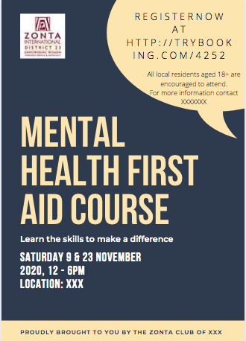
Include the MHFA Australia logo on your promotional materials – your instructor can provide this.

Appendix 4 – Summary of actions

 | STEP | COMPLETE?
1 | Research if there is any current MHFA courses for adults in your area
2 | Assign a local coordinator/s from your Zonta Club
3 | Decide on funding options for the project
4 | Seek quotes from an MHFA instructor, or decide to train someone to deliver the course
5 | Decide on date/s and book a venue
6 | Work out how people can book onto the course e.g. TryBooking and whether you will charge a registration fee
7 | Promote the project early and widely and engage with your local community
8 | Organise catering
9 | Run the course & collect evaluation forms
10 | Read evaluations and complete reflections page
11 | Decide if you will run a follow up with the training group and organise
12 | Email a copy of evaluations and reflections page to the D23 Project Coordinator, Judy Rothe

