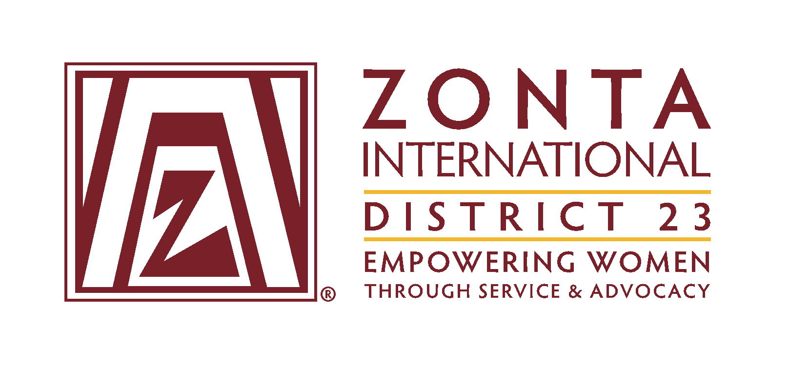
ABN 35181 681 594

INSURANCE NOTIFICATION OF EVENTS

The Insurer requires Clubs to complete this notification when their planned event (other than Birthing Kit and Breast Cushion Assembly Events and Sausage Sizzles) includes any of the Notifiable Events listed on page 2. The Insurer will review the information and confirm cover for the event or otherwise.

Email your completed notification two weeks before the event to –
laura.billington@ajg.com.au
cc lyn.symons@gmail.com

BROKER - Laura Billington
Account Executive, Brisbane Commercial,
Gallagher Insurance Brokers
Mobile: +61 418 657 691
Fax: +61 7 3367 5100
laura.billington@ajg.com.au

POLICY NUMBERS
Liability Insurance QBE Policy no. 1GQU188336BPK
Voluntary Workers Group Personal Accident/Illness AHI Policy no. 5571292

CLUB NAME
CONTACT PERSON
CONTACT DETAILS

EVENT DESCRIPTION
WHEN Date and Time
WHERE
NUMBER OF VOLUNTEERS & ATTENDEES
NOTIFIABLE EVENTS
IS ATTENDANCE EXPECTED TO BE MORE THAN 150 PATRONS?
DOES THE EVENT INVOLVE ANIMALS AND/OR AMUSEMENT RIDES?
(details to be provided)
IS THE CLUB IN CONTROL OF CONTRACTORS?
(particularly contracted Security, Health & Safety and/or other specialised personnel including but not limited to Bouncers, crowd control, traffic control staff, riggers, etc)
IS ALCOHOL OR SIMILAR INVOLVED?
Is the Zonta Club directly in control of the service of alcohol or directly in control of the contractors providing the service of alcohol? If the event is at a licensed premise and the premise owners/occupiers are responsible for the service of alcohol, then notification is not required.
If the answer is “yes” – you must provide details of who is responsible for serving and if they hold a current RSA certificate.
IS FOOD and/or SERVICE PROVIDED?
Is the Zonta Club directly involved in the provision and/or serving of food where there will be more than 150
attendees?
If the answer is yes – you must provide details of who is responsible and if they hold a current food safety certificate

