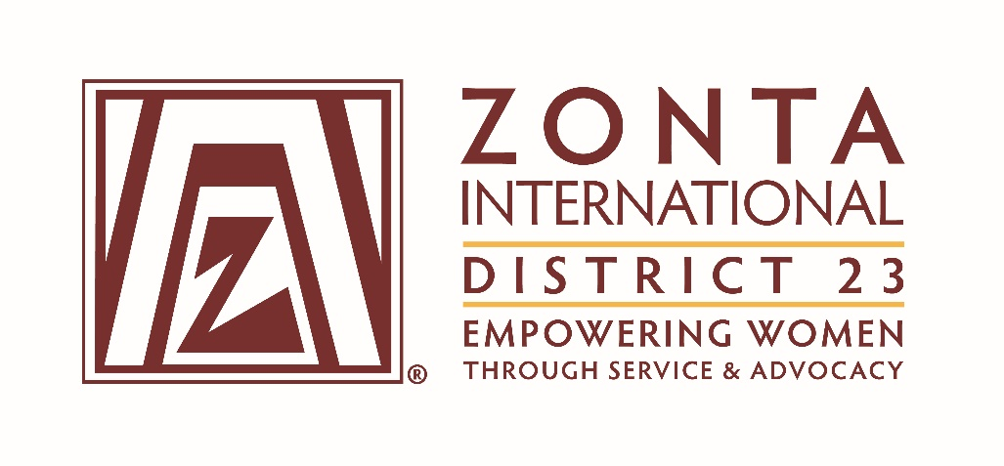

CERTIFICATE

of

MEMBERSHIP

for
XXXXX
Zonta Club of XXXX Inc.

Welcome to a worldwide fellowship of members from all cultures and backgrounds working together to build a better world for women and girls.

Debbie Schmidt
Induction date: XXXXXX
Debbie Schmidt
District 23 Membership Chair
Lieutenant Governor 2022-2024

