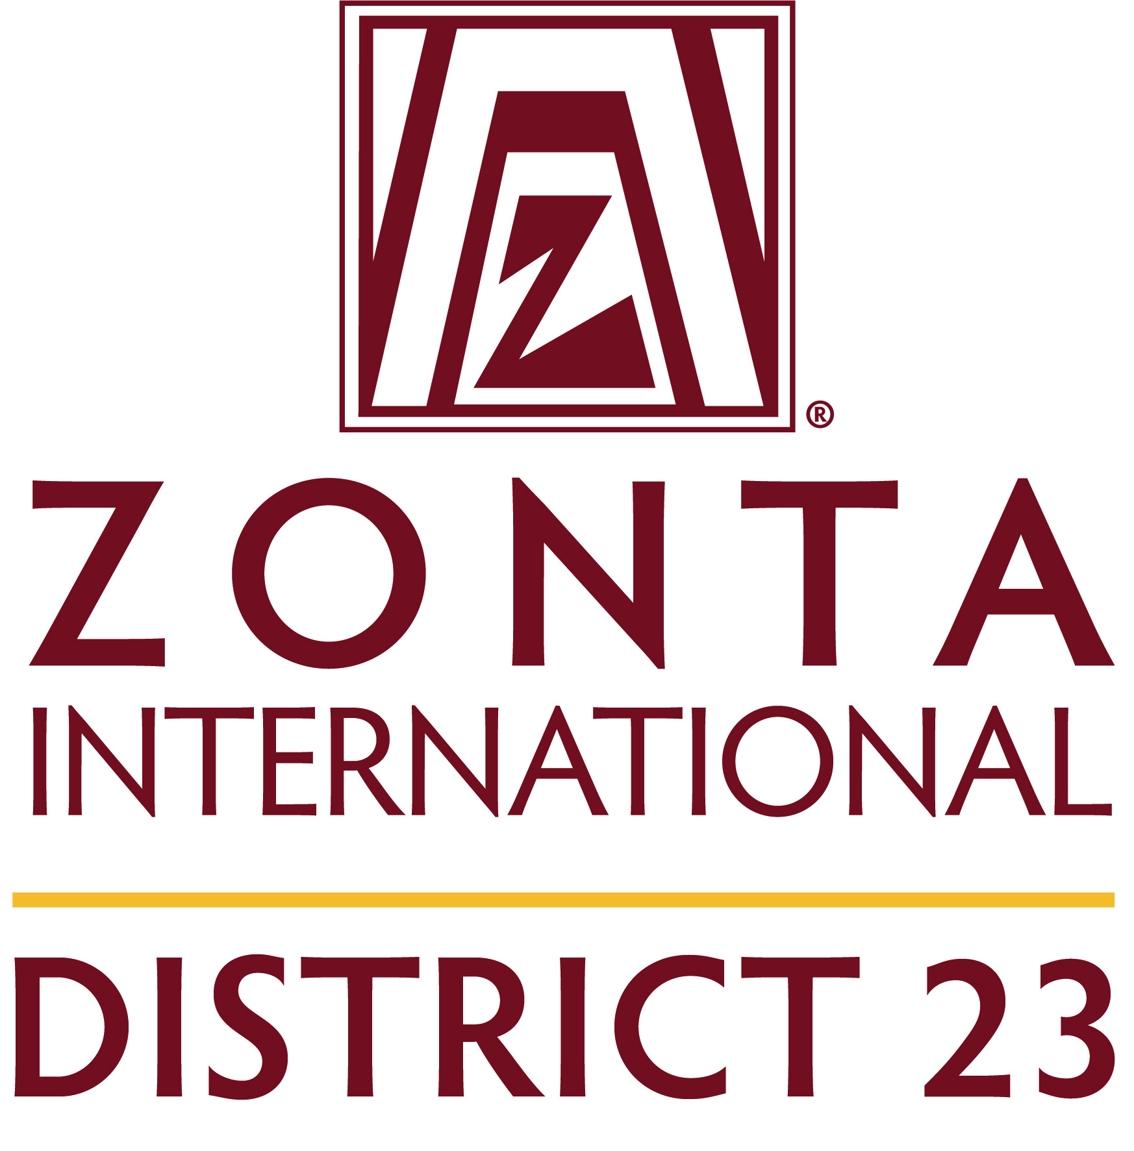
District 23 Greater Visibility Awards 2023
Entries must show evidence of actions taken to work towards achieving these goals.

AWARD ENTRY COVERSHEET
Please tick what you are submitting in each category

ZONTA CLUB OF ________________________________
Contact Person ___________________________ Phone__________________
Category 1 – Stand Out for Gender Equity

- Newsletters □
- Flyers □
- Brochures □
- Website postings □
- Videos □
- Social media postings □
- Posters and / banners □
- Media coverage including radio or TV interviews/podcasts, articles □
- Event program content □
Category 2 – Represent Global Citizenship
- Newsletters □
- Flyers □
- Brochures □
- Website postings □
- Videos □
- Social media postings □
- Posters and / banners □
- Media coverage including radio or TV interviews/podcasts, articles □
- Event program content □

Category 3 – Develop Future Leaders
- Newsletters □
- Flyers □
- Brochures □
- Website postings □
- Videos □
- Social media postings □
- Posters and / banners □
- Media coverage including radio or TV interviews/podcasts, articles □
- Event program content □
- Other □

Category 4 - Celebrate Ourselves
- Newsletters □
- Flyers □
- Brochures □
- Website postings □
- Videos □
- Social media postings □
- Posters and / banners □
- Media coverage including radio or TV interviews/podcasts, articles □
- Event program content □
- Other □

Category 5 – Position Zonta for the Future
- Newsletters □
- Flyers □
- Brochures □
- Website postings □
- Videos □
- Social media postings □
- Posters and / banners □
- Media coverage including radio or TV interviews/podcasts, articles □
- Event program content □
- Other □

